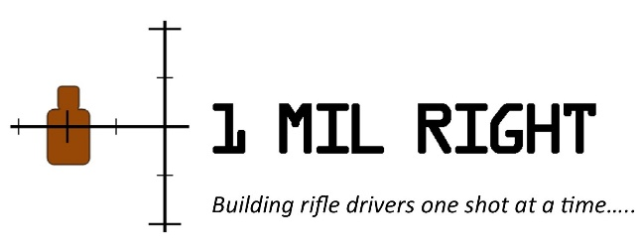

REGISTRATION FORM
Basic Law Enforcement Sniper/F.O. Certification Course
DATE: December 12th – 16th, 2022
LOCATION: Louisiana State Police / Joint Emergency Services Training Center. Zachary, LA
5 Day / 50+ hours. Including 3 nights of low light/no light operations.

NAME OF ATTENDEE: _______________________ _______ __________________________
Agency/ Department: __________________________________________________________
Age: ________ Sex: _______
Attendee Phone Contact Number: ________ ___________________
Attendee Email Contact Address: ________________________________________________
Completed some form of Basic SWAT Operations School? ____________________________
Completed any other Basic L.E. Sniper School(s)? ___________________________________
Background: __ Civilian (Industry) __ Current Military __ Former Military
__ Current Law Enforcement __ Former Law Enforcement __ Instructor
__ First Responder (Fire/EMS) __ Gov’t Employee / Contractor
Supervisor or Team Leader contact in case of emergency:
Name: ________________________________________ Position: __________________
Phone (24hr) : _______ _______ ________________
Email: _______________________________________
COURSE TUITION: $850.00 U.S.D. *Lodging and Food services paid and reserved separately through J.E.S.T.C. per class announcement flier.
Tuition payable to 1 Mil Right, LLC.
Terry@1MilRt.com www.1MilRt.com Terry Cross cell (318) 729 7631
Suite B 1405 Frank Andrews Blvd. Alexandria, LA 71303

